Prompt 1

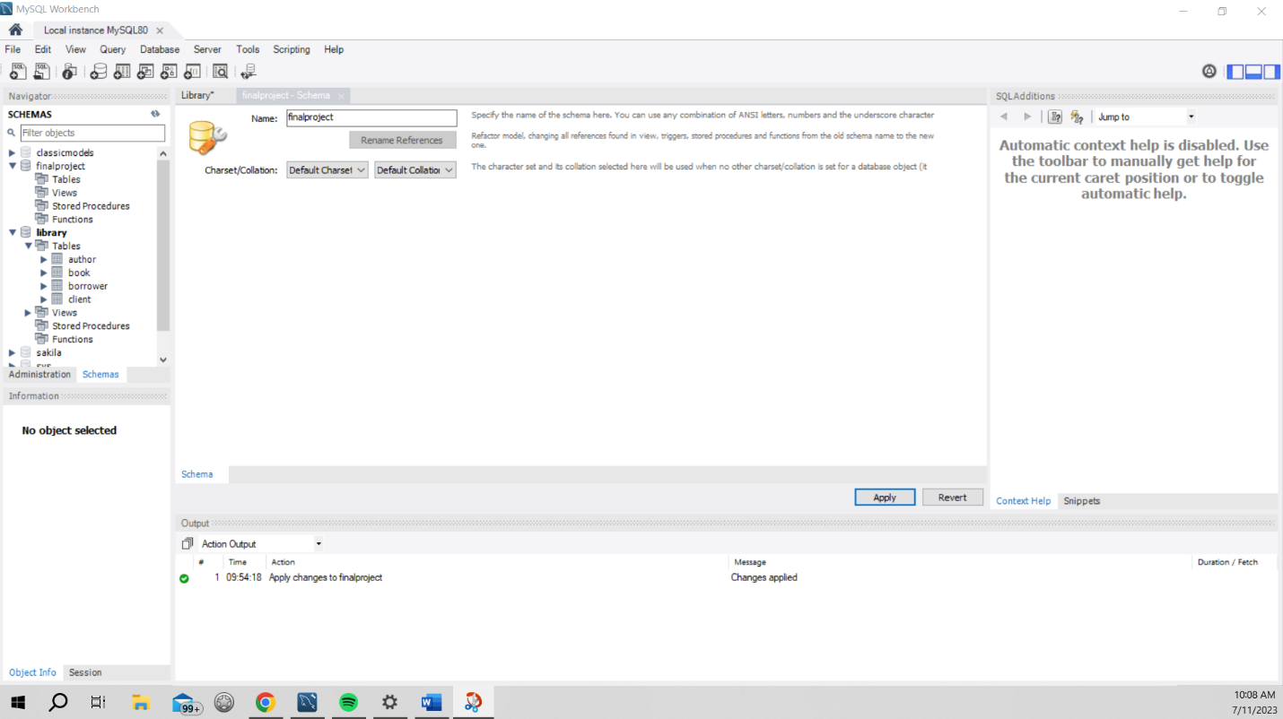

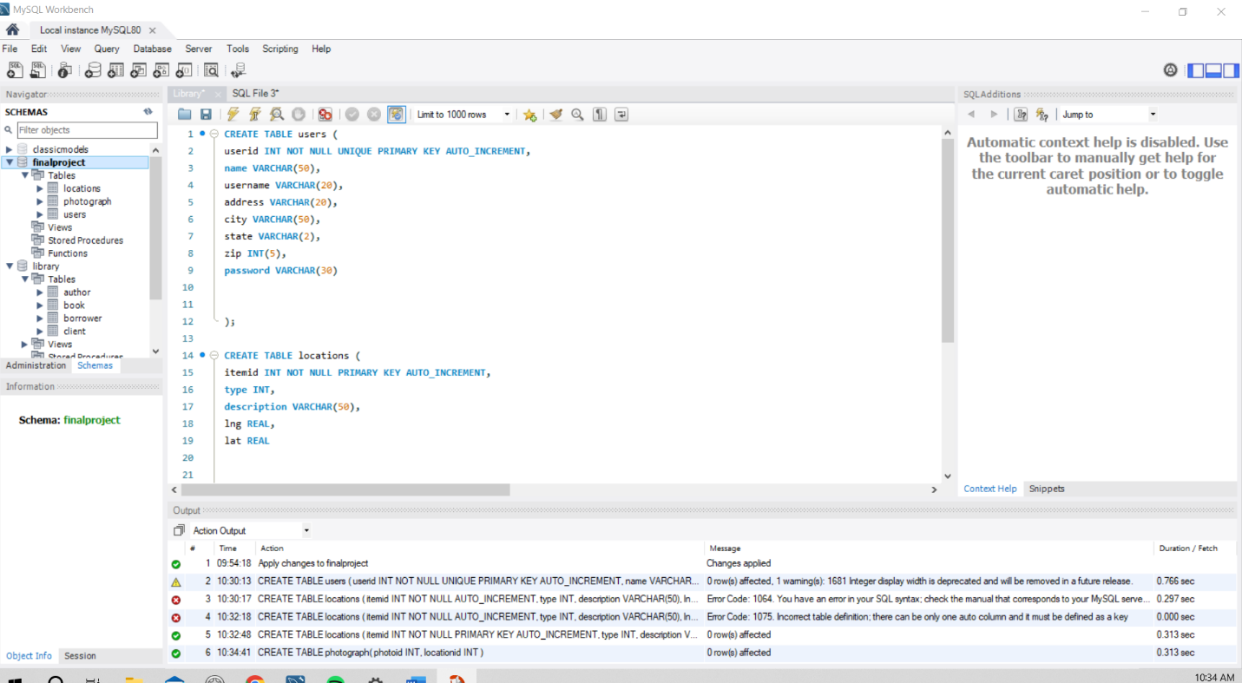

CREATE TABLE users (

userid INT NOT NULL UNIQUE PRIMARY KEY AUTO_INCREMENT,

name VARCHAR(50),

username VARCHAR(20),

address VARCHAR(20),

city VARCHAR(50),

state VARCHAR(2),

zip INT(5),

password VARCHAR(30)

);

CREATE TABLE locations (

itemid INT NOT NULL PRIMARY KEY AUTO_INCREMENT,

type INT,

description VARCHAR(50),

lng REAL,

lat REAL

);

CREATE TABLE photograph(

photoid INT,

locationid INT

);

Prompt 3-Alter Tables

ALTER TABLE locations MODIFY type INT NOT NULL;

ALTER TABLE locations MODIFY description VARCHAR(50) NOT NULL;

ALTER TABLE locations MODIFY lng REAL NOT NULL;

ALTER TABLE locations MODIFY lat REAL NOT NULL;

ALTER TABLE users MODIFY name VARCHAR(50) NOT NULL;

ALTER TABLE users MODIFY username VARCHAR(20) NOT NULL;

ALTER TABLE users MODIFY password VARCHAR(30) NOT NULL;

ALTER TABLE photograph MODIFY photoid INT NOT NULL;

ALTER TABLE photograph MODIFY locationid INT NOT NULL;

Prompt 4

CREATE UNIQUE INDEX id ON users (userid);

CREATE UNIQUE INDEX pid ON photograph (photoid);

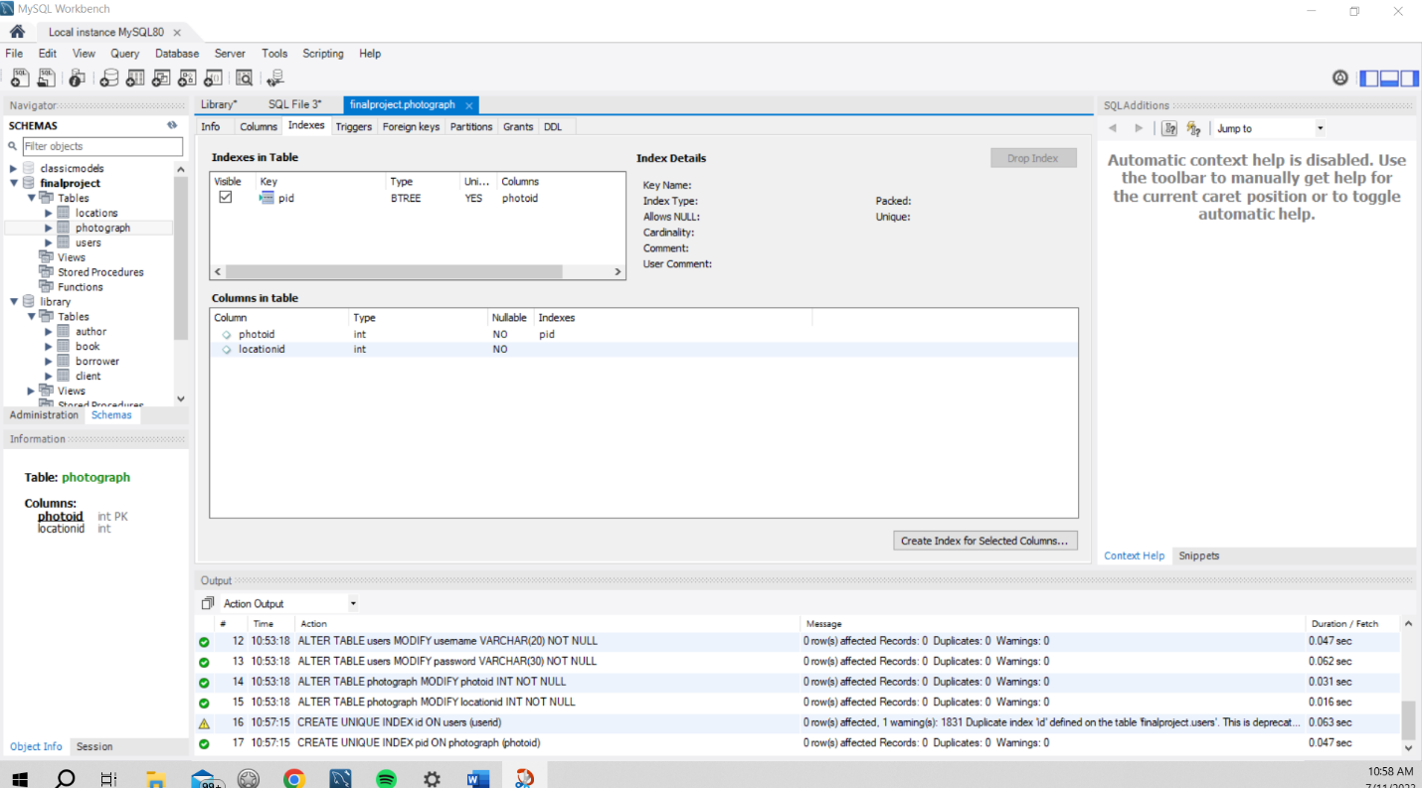

Prompt 5

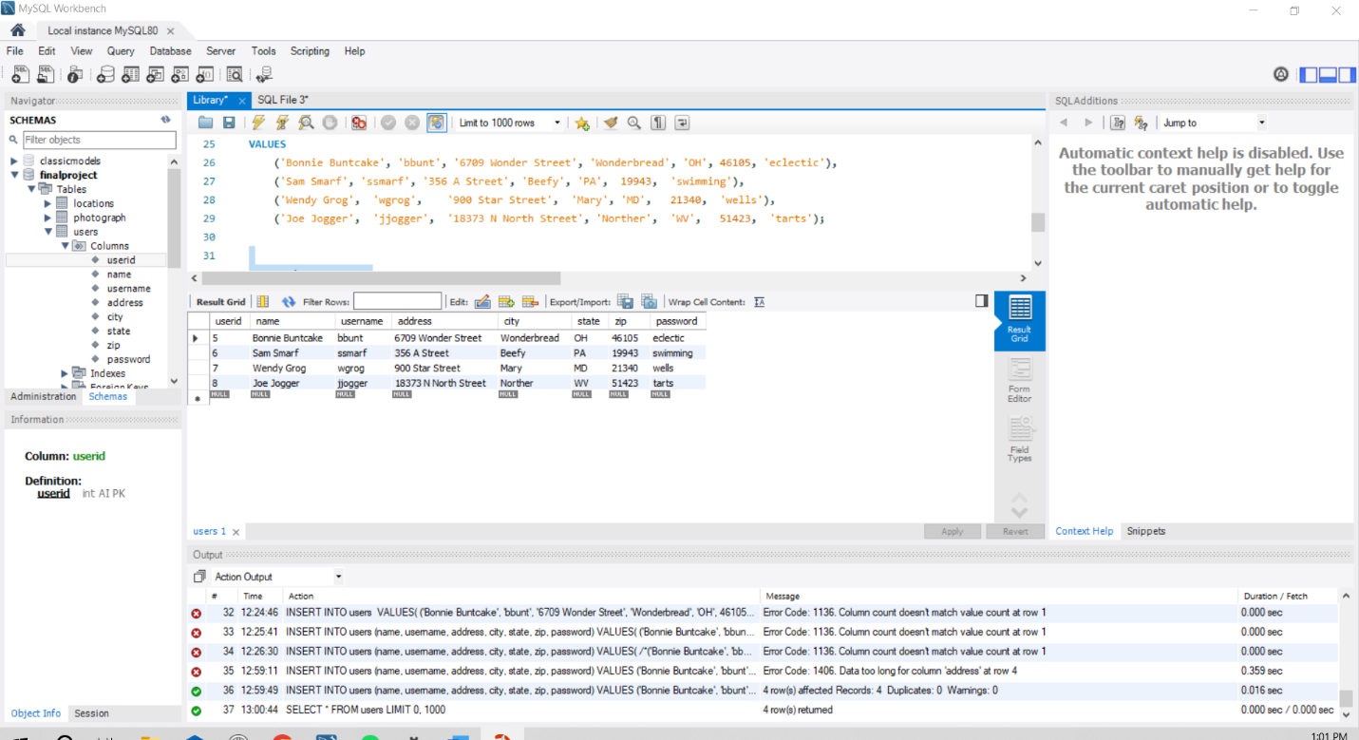

Prompt 6

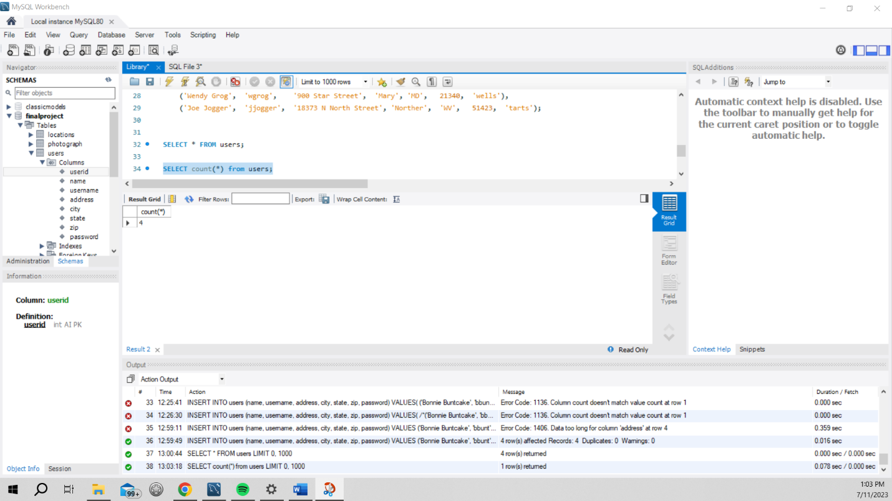

Prompt 7

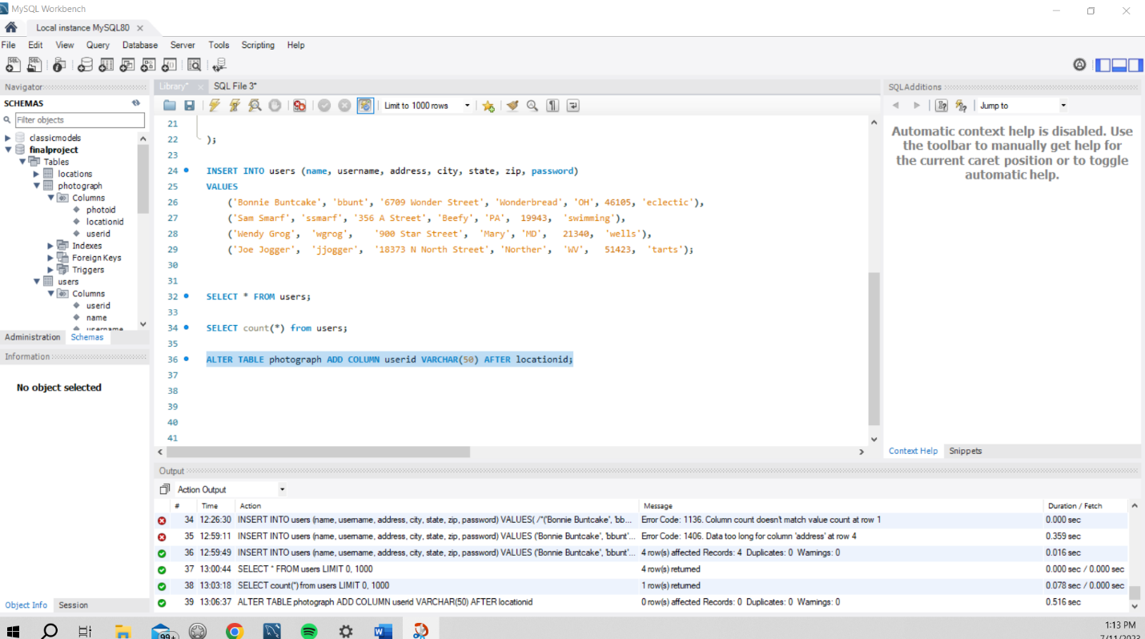

Prompt 8

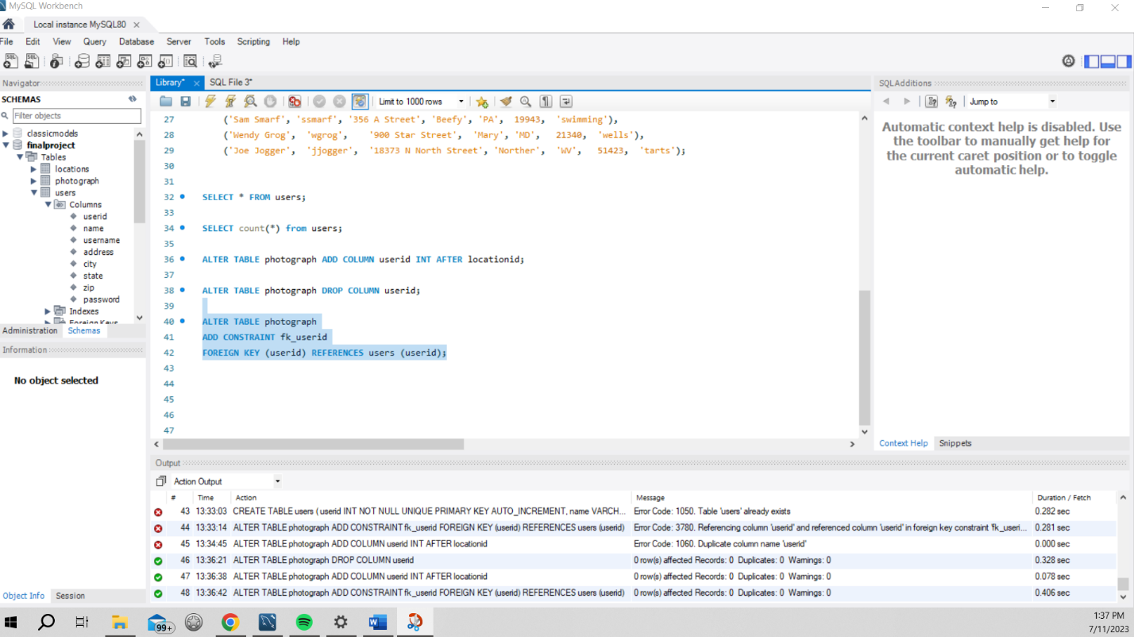

By updating the column to be a foreign key that references the primary key in the users table, the data in the tables becomes interconnected, enabling deeper analysis and exploration of the information. This crucial relationship allows for the retrieval of meaningful insights by linking related data points. Without establishing these connections, the tables would function as separate entities, lacking the ability to provide valuable context or facilitate comprehensive data analysis. By leveraging foreign key constraints, the tables can now work in tandem, enabling researchers to uncover correlations, dependencies, and patterns that would otherwise remain hidden in isolation. This integration enhances the overall data comprehension and empowers more informed decision-making processes.

PROMPT 9

INSERT INTO locations (type, description, lng, lat)

VALUES (1, 'Independence Hall', 794.35, 651.43),

(2, '6709 Wonder Street', 323.41, 412.22),

(1, 'Sunrise', 221.45, 132.43),

(2, '356 A Street', 123.32, 222.43),

(1, 'Mountains', 34.12, 87.99),

(2, '900 Star Street', 1071.9, 206.45),

(1, 'Moonrise', 816.2, 111.2),

(2, '183714 N North Street', 176.11, 11.176);

INSERT INTO photograph (photoid, locationid, userid)

VALUES (1, 1, 5),

(2, 2, 5),

(3, 3, 6),

(4, 4, 7);

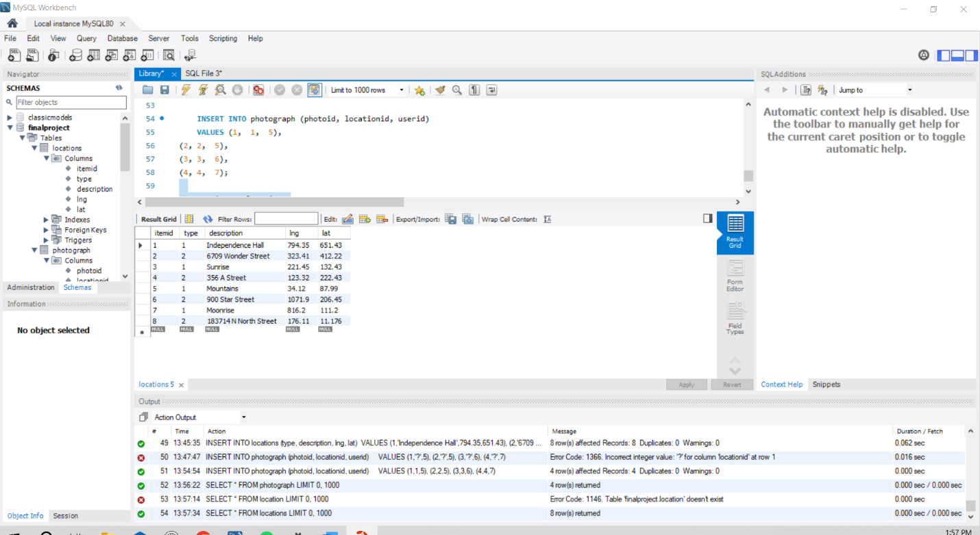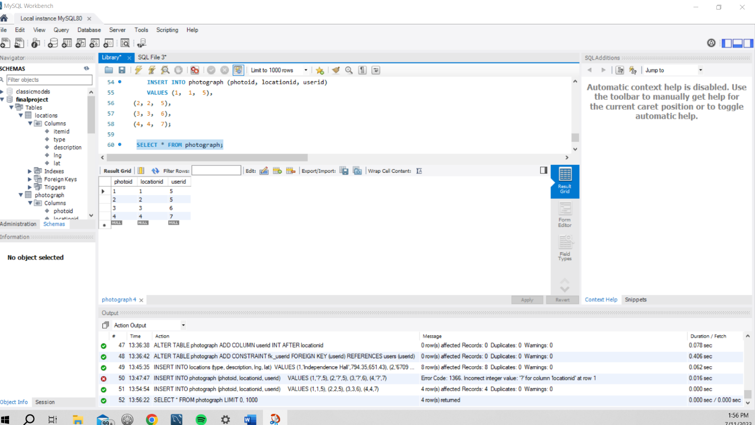

Prompt 10

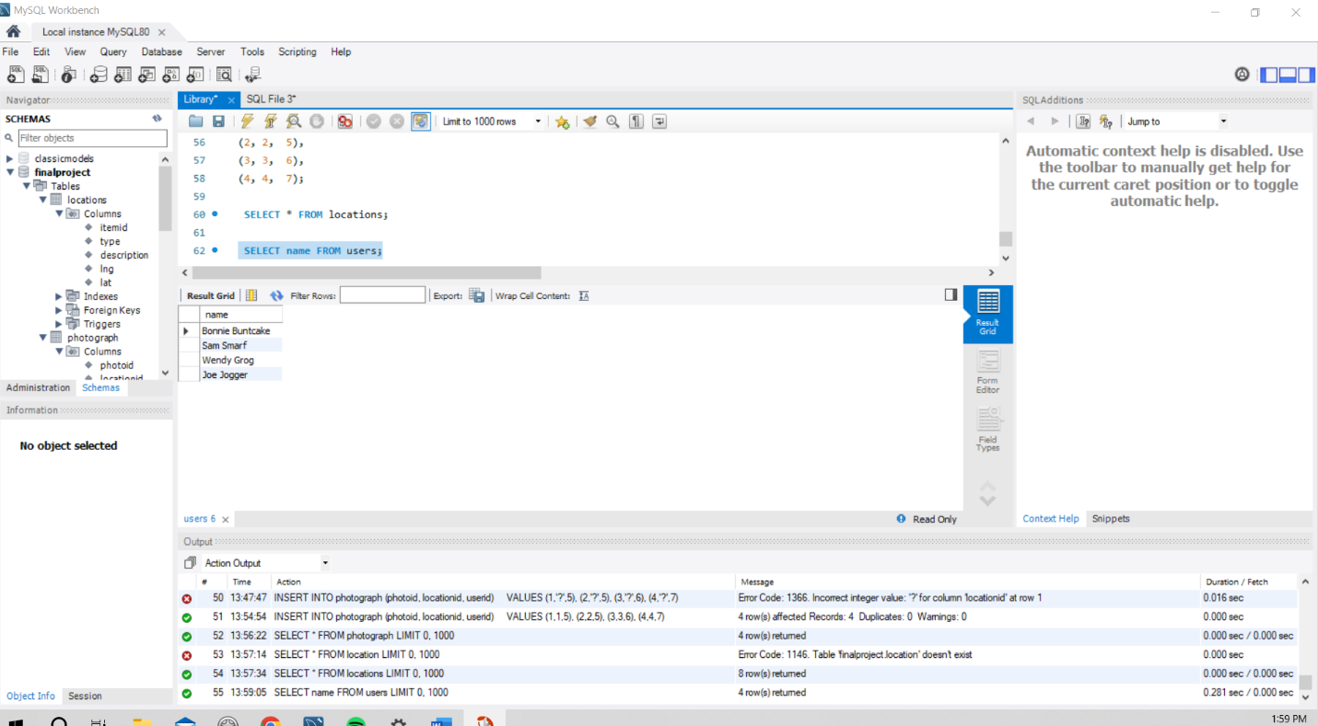

PROMPT 11

SELECT name FROM users, photograph WHERE users.userid = photograph.userid;

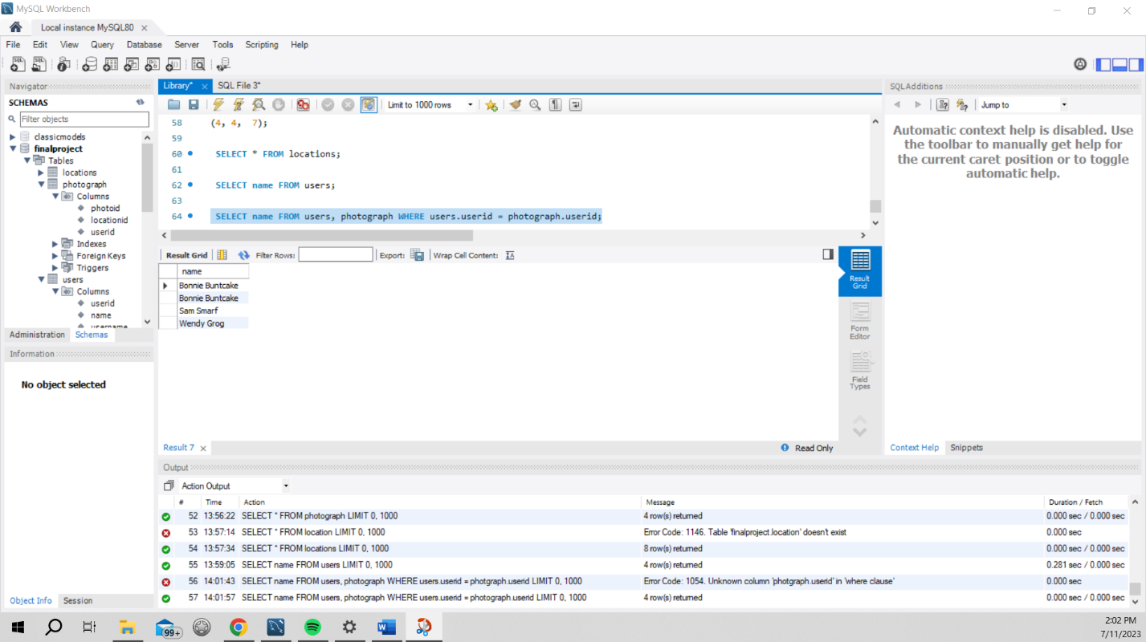

Prompt 12

SELECT DISTINCT name FROM users, photograph WHERE users.userid = photograph.userid;

